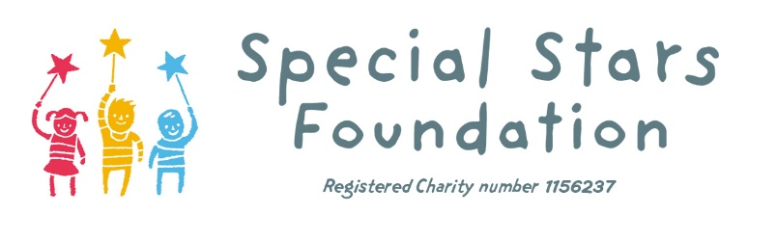

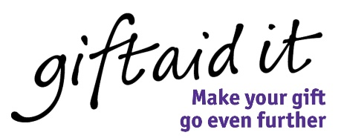
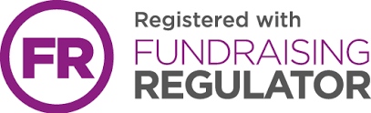

Gift Aid declaration – for past, present & future donations
Boost your donation by 25p of Gift Aid for every £1 you donate
Gift Aid is reclaimed by the charity from the tax you pay for the current tax year Your address is needed to identify you as a current UK taxpayer

I want to Gift Aid any cash and product donations I make in the future or have made in the past 4 years to Special Stars Foundation (please tick)

I am a UK taxpayer and understand that if I pay less Income Tax and/or Capital Gains Tax than the amount of Gift Aid claimed on all my donations in that tax year it is my responsibility to pay any difference (please tick)

My Details
Mr/Mrs/Ms/Miss/Dr/Prof/Other:____________________

First Name____________________________________

Surname______________________________________

Address (please inc postcode)___________________________________________________

____________________________________________________________________________
Telephone:___________________________________________________________________

Email address:________________________________________________________________

Signed:____________________________________ Date:_____________________________

Please notify the charity if you:
- Want to cancel this declaration
- Change your name or home address
- No longer pay sufficient tax on your income and/or capital gains.
If you pay Income Tax at the higher or additional rate and want to receive the additional tax relief due to you, you must include all your Gift Aid donations on your Self Assessment tax return or ask HM Revenue and Customs to adjust your tax code.

